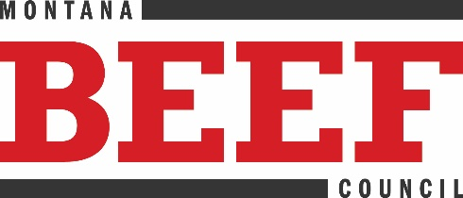
Montana Beef Council
2795 Enterprise Ave., Ste. 4
PO Box 80865
Billings, MT 59108
(406) 656-3336
www.montanabeefcouncil.org

NEWS RELEASE CONTACT INFO
December 8, 2021 Chaley Harney, Executive Director
FOR IMMEDIATE RELEASE (406) 855-2857
chaley@montanabeefcouncil.org

Ten Days of Giveaways
Beef up your holiday season and support Montana’s restaurants and ranchers

BILLINGS, MONTANA – The Montana Beef Council (MBC) is bringing cheer to restaurant dining rooms across the state during their 10 Days of Giveaways promotion. As a spin-off to their successful “Half-Off Promotion” from last spring where diners enjoyed a full day of half-off beef meals at a variety of Montana restaurants, this holiday version will select one winner in 10 Montana cities to receive their beef meal for half off, and MBC will pay up to $150.00 per winner.

“This is a great way to highlight beef and the talent of our foodservice industry with a delicious beef meal at a great value this holiday season,” said Chaley Harney, Montana Beef Council executive director. “Beef brings people to the table, and we are always looking for ways to do just that. This goodwill promotion helps Montana’s foodservice industry, and Montana’s beef-loving consumers, and Montana’s hardworking ranchers.”

The promotion will select one winner each day in December to receive their beef meal at half-off from the participating restaurant in each city. Winners will be selected through the Montana Beef Council’s Facebook page. Cities include Billings, Great Falls, Bozeman, Butte, Havre, Anaconda, Miles City, Sidney, Lewistown, and Dillon.

#####
Montana Beef Council is organized to enhance profit opportunities for Montana cattle and beef producers by increasing demand for beef and beef products.

