NEWS RELEASE CONTACT INFO
January 3, 2022 Chaley Harney, Executive Director
FOR IMMEDIATE RELEASE (406) 855-2857
chaley@montanabeefcouncil.org

Montana Beef Council Welcomes New Team Member
New staff member will serve as statewide ambassador for Montana Beef Council

BILLINGS, MONTANA – The Montana Beef Council (MBC) is pleased to announce the addition of Al Koenig to the Montana Beef Council staff team as the Field Representative. Al’s primary role will be to serve as a brand ambassador for the MBC and represent the Beef Checkoff to Montana’s producers. His first day is January 3, 2022.
Al was raised in Belgrade, Mont. and holds a Bachelor of Science in Agricultural Business and a Bachelor of Science in Economics with minors in Finance, Spanish, Business Administration, and International Business. Previously he served as the Montana FFA State President, taught entry-level economics, and worked abroad to represent the beef and cattle industry. He has traveled extensively both in and out of state and brings a vast network of contacts in the beef community to the Council. In addition to working for MBC, Al also maintains his cattle herd in Gallatin, Broadwater, and Jefferson counties.
The Montana Beef Council was created in 1954 by cattlemen as a marketing organization for beef and is funded through the federal mandatory $1-per-head Beef Checkoff assessment. Montana Beef Council is organized to enhance profit opportunities for Montana cattle and beef producers by increasing demand for beef and beef products.

#####

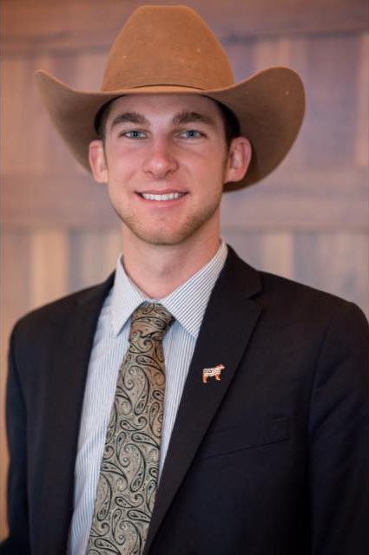
Al Koenig, MBC Field Representative

