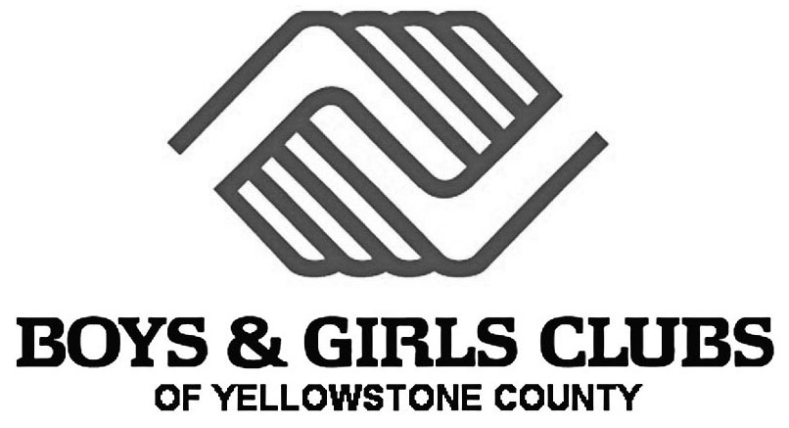

*FOR IMMEDIATE RELEASE*

Date: July 8, 2021

3 Nonprofits partner for “Built from Beef” Events

Billings, MT – Monday July 12, 2021, is the first of three “Built from Beef” events happening this summer with three area non-profits partnering to bring learning opportunities to youth in Yellowstone County. Throughout this summer, over 200 youth from the Boys & Girls Clubs of Yellowstone County will have an opportunity for experiential, hands on learning during the “Built from Beef” events; while also enjoying the fun and amazing atmosphere of the historic Billings Depot.

Hosted by the Montana Beef Council, “Built from Beef” will feature three different stations for Club members to experience during their field trip to the historic Billings Depot. The first station will feature a STEM category where the children will discover the essential nutrients found in beef through experiential learning. The second station will feature basic kitchen skills and ways for children to be helpful in the kitchen when preparing beef meals. The final station will feature a lesson in Montana cattle brands and allow the children to design their own brand as well as learning a helpful ranching skill as they practice roping a steer head with help from some cowboys.
“We are thankful for this collaboration of missions to educate, interact and inspire kids. We have received a great response from area chefs like Sarah Moyer- owner and operator of Project Lunch and founder of Eat.Share.Give, Paul Lamantia- head firemaker from Blue Line BBQ, Jonathan Reyes- executive chef from By All Means Brewery and Jeremy Evans- friendly neighborhood kitchen-man and professional chef. All these individuals are just as excited as we are to share a skill with our young people that will help them throughout their lives,” says Chaley Harney, Executive Director for the Montana Beef Council.
The Montana Beef Council is organized to enhance profit opportunities for Montana cattle and beef producers by increasing demand for beef and beef products.

The Boys & Girls Clubs of Yellowstone County’s mission is to enable all young people, especially those who need us most, to realize their full potential as productive, caring and responsible citizens. Through the years, the organization has seen a growing need for a safe, engaging and fun place to be during out of school time. The Club has grown from serving 70 members in one location in 1971 to serving over 350 members (over 550 pre-pandemic) in 5 Clubhouses and 5 Micro-site locations in 2021.

Photo Opportunities

We invite the media markets to a photo opportunity on Monday July 12th at the historic Billings Depot from 9:30 to 3:30.

For More Information
Chaley Harney
Executive Director
Montana Beef Council
PO Box 80865
2795 Enterprise Avenue. Suite 4
Billings, MT 59108
Office: 406-855-2857
chaley@montanabeefcouncil.org

Michelle Williams
Executive Director
2310 Montana Ave, Billings, MT 59101
Billings Depot
Office: (406) 656-7273
Mobile: (469) 358-0180
MichelleWilliams@billingsdepot.org

Karrie Owen
Vice President, Donor Engagement & Marketing
Boys & Girls Clubs of Yellowstone County
505 Orchard Lane
Billings, MT 59101
Office: 406-294-4511
kowen@bgcyellowstone.org

