DUE AUGUST 1 Date application submitted: ______________

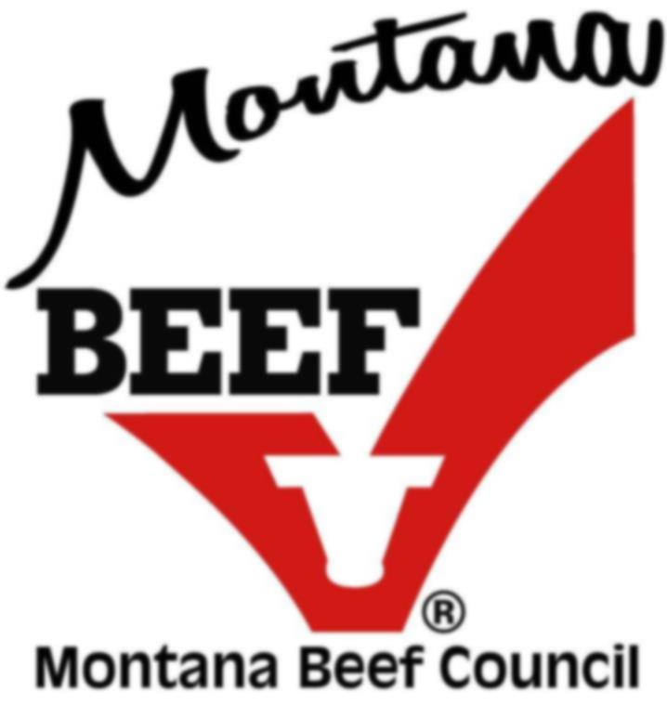
MONTANA BEEF COUNCIL PROJECT FUNDING REQUEST FORM

STRATEGIC PRIORITIES met through this project: (Select all that apply) FOR INTERNAL USE ONLY:

Grow consumer trust in beef & beef production Committee:
Promote & capitalize on the multiple advantages of beef Education
Drive growth in beef exports (international only) Promotion
Inform & educate beef checkoff investors Research
GOALS met through this project: (Select all that apply) Producer Communication

Increase the frequency of consumers choosing beef Montana Research
Retain beef’s position as a leader in the market
Turn our beef believers into advocates
Reinforce beef’s value proposition

Business Name: Primary Contact:

Address, City, State, Zip:

Phone: E-mail:

Describe the organization’s purpose and its primary activities/services:

Indicate the geographical area served:

Project/Event Name:

Project/Event activation date(s): Single Multiple

Checkoff dollar amount requested:

Target demographic to be reached:

Target audience number to be reached:

Description:

Is there an opportunity for a member of MBC to participate or make a presentation? Yes No
Is this an annual project/event and if so, is future funding likely to be requested? Yes No
I agree to utilize and complete the MBC Evaluation Form with measurable objectives: Yes No

Please enclose the following information:

- Board of Directors of your organization
- Itemized budget for the project/event

- Current annual operating budget
- Current audited financial report

Return completed form to: (submit via email if possible)
E-mail: info@montanabeefcouncil.org Questions? Call (406) 656-3336

